1. **Add New in Inventory API**

* URL: <http://localhost:55905/AddProduct>
* Type: POST
* **PayLoad:**

**Request**

{

    "ProductName":"Sky Light",

    "ProductDescription":"white in colour",

    "ProductPrice": 1000.50,

    "CreatedBy": 1 -- User Id who created the product, integer type

}

**Response**

{

     "IsSuccess": **true**,

     "Message": "PRODUCT ITEM CREATED SUCCESSFULLY"

}

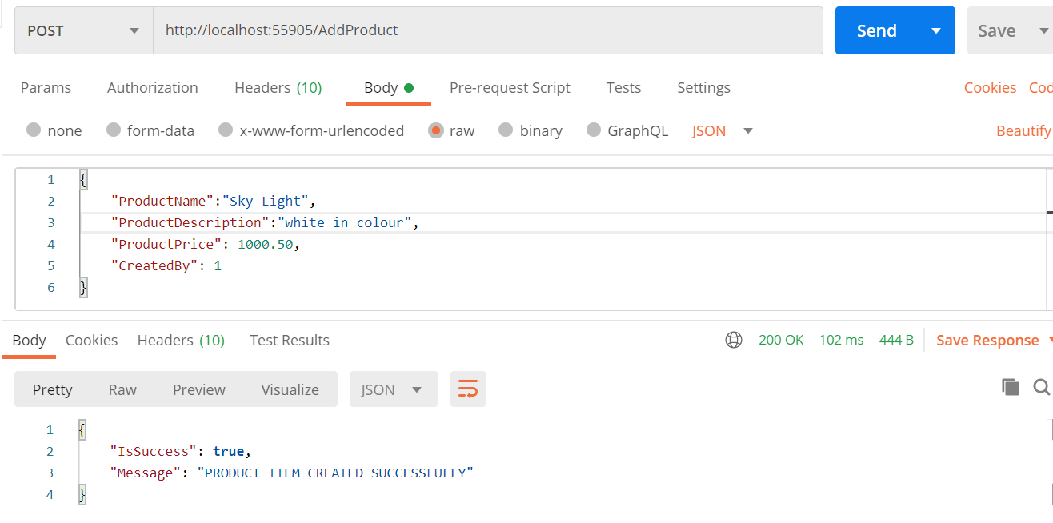

1. **Modify Existing Item in Inventory**

* **URL:** <http://localhost:55905/ModifyProduct>
* **Type: POST**
* **Payload**

**Request**

{

    "ProductId":1, // Unique Id of Product

    "ProductName":"Sky Light New",

    "ProductDescription":"white in colour",

    "ProductPrice": 1000.50,

    "ModifiedBy": 1, // user who modified the product

    "IsActive": **true // maintain the status of product by true or false**

}

**Response**

{

    "IsSuccess": **true**,

    "Message": "PRODUCT ITEM UPDATED SUCCESSFULLY"

}

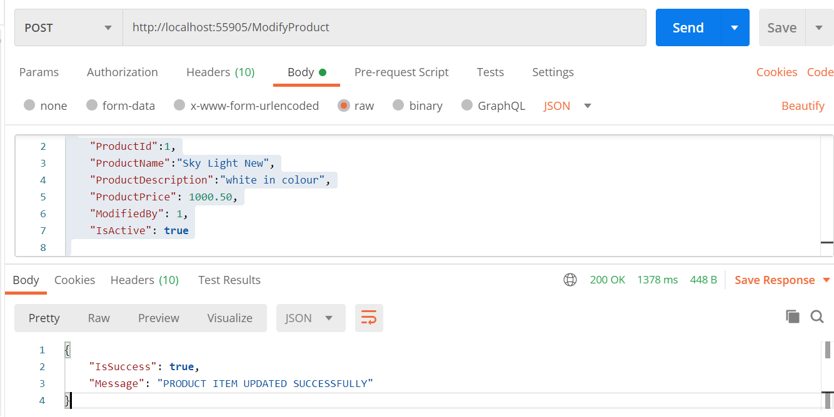

1. **Delete an item from Inventory**

* **URL:** <http://localhost:55905/DeleteItem?ProductId=1>
* **Type :** DELETE
* **Response Payload:**

{

    "IsSuccess": **true**,

    "Message": "PRODUCT ITEM DELETED SUCCESSFULLY"

}

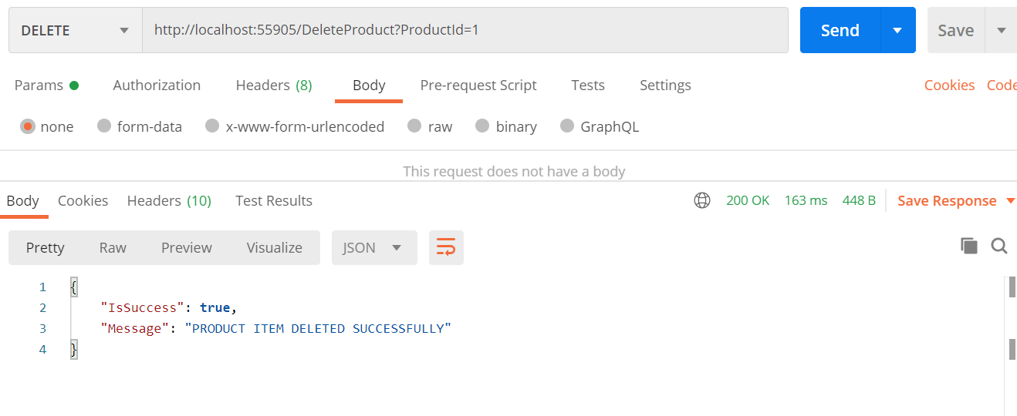

1. **List the items in Inventory**

* **URL:** <http://localhost:55905/ListProduct>
* **Type:** GET
* **Response Payload**

{

    "Data": [

        {

            "ProductId": 2,

            "ProductCode": "2407142021021953",

            "ProductName": "Sky Light",

            "ProductDescription": "white in colour",

            "ProductPrice": 1000.50,

            "IsActive": **true**,

            "CreatedDate": "2021-07-24T14:19:53.73",

            "CreatedBy": 1,

            "ModifiedDate": **null**,

            "ModifiedBy": **null**

        }

    ],

    "IsSuccess": **true**,

    "Message": "Success"

}

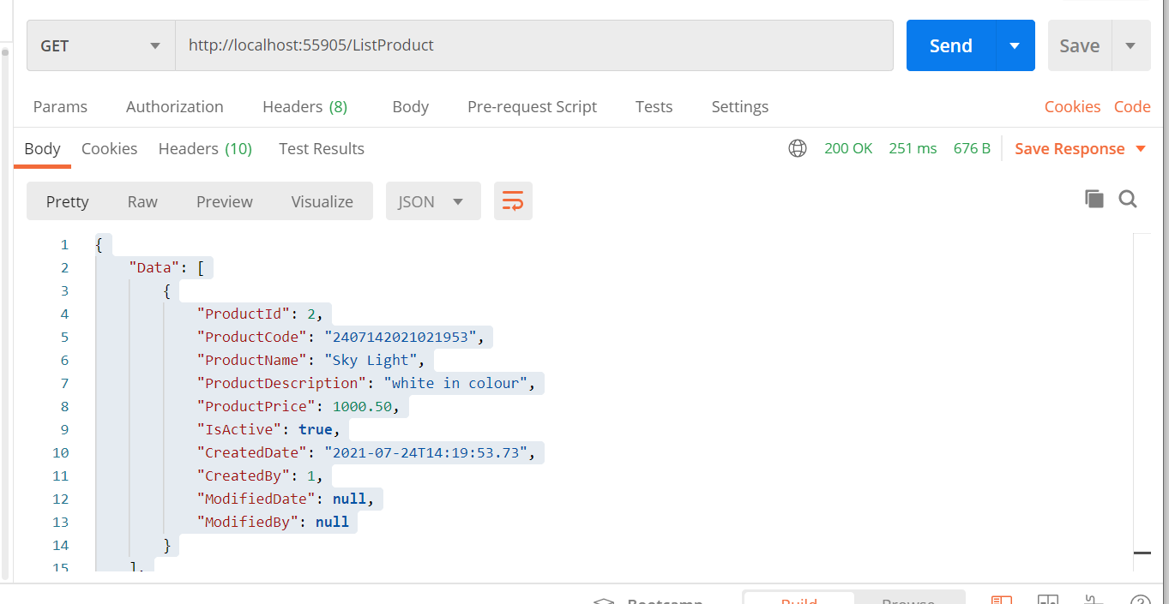

**Time duration spent**

* **Data Storage Design : 0.5 hrs**
* **API and Service Logic: 1 hrs**
* **Unit testing : 0.5 Hrs**